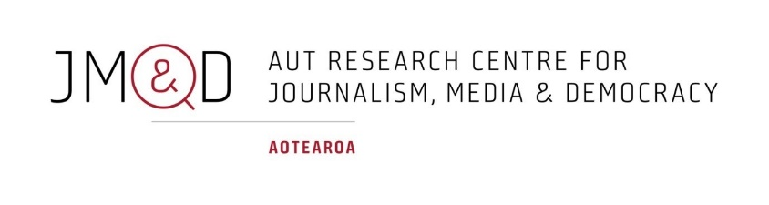
MEDIA RELEASE
Trust in news up significantly; journalism sees revival as a trusted source
Embargoed until April 15, 2026, 04:59 am
The AUT Journalism, Media and Democracy research centre (JMAD) has published its seventh annual Trust in News in Aotearoa New Zealand report, authored by Dr Merja Myllylahti and Dr Greg Treadwell.
The report finds that after six years of decline, in 2026, trust in news improved significantly. New Zealanders’ general trust in news increased from 32% in 2025 to 37%, and approximately 50% (+5pp) of people trusted the news they consumed themselves.

- RNZ was perceived as the most trusted news brand, followed by the Otago Daily Times (2nd) and TVNZ (3rd)
- Discomfort with news mostly produced by AI was unchanged at 60%
- News avoidance has significantly increased, up five percentage points to 78%
- Transparency, high journalistic standards and editorial independence remain key aspects to building trust
- Online news sites and apps were the main news sources for 38% of New Zealanders
- TV was the main source of news for 20% of New Zealanders, while 19% mentioned social media/video networks as their main source of news

The role of news media as a trusted source of verified, professionally produced news and information has been confirmed in 2026’s survey.

“As social media and video platforms are flooded with influencers, disinformation, and AI content, people are increasingly using news media for information verification. That is promising,” says the report’s co-author Dr Merja Myllylahti.

The 2026 trust survey also examined New Zealanders’ attitudes to editorial independence. It shows approximately 43% of New Zealanders believe interference by media owners/boards or managers with editorial decisions would decrease their trust in the media, with 27% considering cancellation of subscription/payment if that happens.

Furthermore, 46% of those surveyed were extremely or very concerned about politicians publicly discrediting news.

“New Zealanders are sending a clear message to media owners and politicians, telling them not to interfere with editorial independence or the credibility of news media in public,” says Myllylahti.

The number of people paying for news via a digital subscription increased slightly to 17% in 2026. Although the highest level of financial support went to the NZ Herald, which faced ownership and board level battles in 2025, it dropped from 22% in 2025 to 18% in 2026.

Co-author Dr Greg Treadwell says trust levels are still alarmingly low and many of the accusations against journalists from earlier research – of political bias and producing opinion rather than news – remain.

But this year’s report also shows many New Zealanders value professional journalism, including its commitment to accuracy and other ethical standards, he says.

He says there was a sense from many people they wanted to push back at online narratives that you can’t trust the news media.

Read the full report on the JMAD website.
-ENDS-

Drs Myllylahti and Treadwell are available for interviews. To arrange, or for high resolution images, contact:
Nicola Hopkins
Senior Faculty Communications Manager
Auckland University of Technology
M: +64 21 844 285
E: nicola.hopkins@aut.ac.nz

Useful links:
Study Journalism at AUT
Journalism, Media and Democracy Research Centre
Trust in News in Aotearoa New Zealand podcasts

Auckland University of Technology (AUT) is one of the world’s best modern universities. Home to 28,000 students across three campuses, AUT has more than 60 research centres and institutes delivering leading research – from artificial intelligence to robotics, and ecology to public health. As a contemporary university, AUT is connected to an extraordinary range of organisations sharing expertise and resources, collaborating on ground-breaking research, and connecting students with industry leaders and employers.

